1. Go to Maintenance Tool
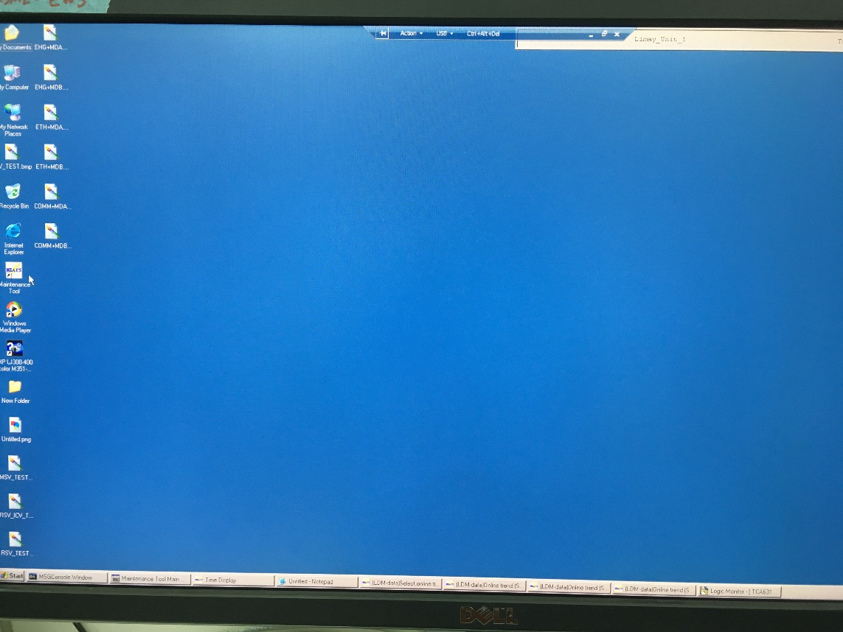

2. Select Switch Controller
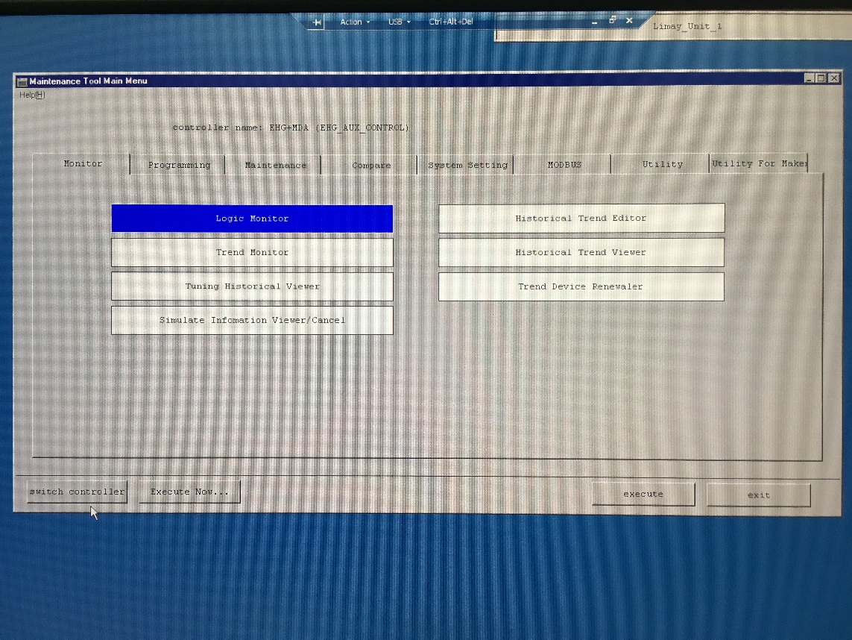
3. Choose what controller (ATS or EHG)
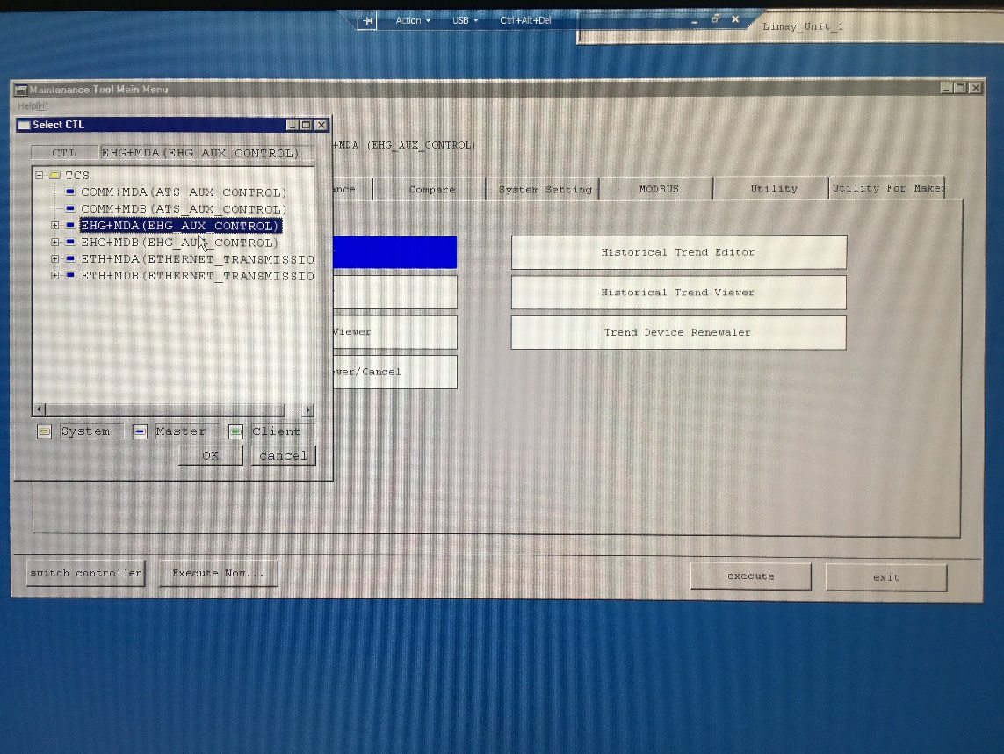

4. Then select OK
5. Double Click Logic Monitor

6. Select which Logic Sheet Number
